[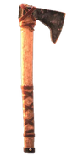](https://lord-of-the-rings-return-to-moria.fandom.com/wiki/Improvised_Axe)

[Improvised Axe](https://lord-of-the-rings-return-to-moria.fandom.com/wiki/Improvised_Axe)

[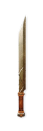](https://lord-of-the-rings-return-to-moria.fandom.com/wiki/Iron_Sword)

[Iron Sword](https://lord-of-the-rings-return-to-moria.fandom.com/wiki/Iron_Sword)

[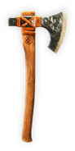](https://lord-of-the-rings-return-to-moria.fandom.com/wiki/Iron_War_Axe)

[Iron War Axe](https://lord-of-the-rings-return-to-moria.fandom.com/wiki/Iron_War_Axe)

[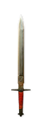](https://lord-of-the-rings-return-to-moria.fandom.com/wiki/Steel_Sword)

[Steel Sword](https://lord-of-the-rings-return-to-moria.fandom.com/wiki/Steel_Sword)

[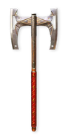](https://lord-of-the-rings-return-to-moria.fandom.com/wiki/Steel_Battleaxe)

[Steel Battleaxe](https://lord-of-the-rings-return-to-moria.fandom.com/wiki/Steel_Battleaxe)

[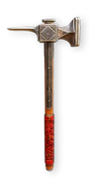](https://lord-of-the-rings-return-to-moria.fandom.com/wiki/Last_Alliance_Maul)

[Last Alliance Maul](https://lord-of-the-rings-return-to-moria.fandom.com/wiki/Last_Alliance_Maul)

[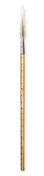](https://lord-of-the-rings-return-to-moria.fandom.com/wiki/Iron_Spear)

[Iron Spear](https://lord-of-the-rings-return-to-moria.fandom.com/wiki/Iron_Spear)

[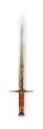](https://lord-of-the-rings-return-to-moria.fandom.com/wiki/First_Age_Sword)

[First Age Sword](https://lord-of-the-rings-return-to-moria.fandom.com/wiki/First_Age_Sword)

[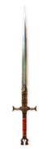](https://lord-of-the-rings-return-to-moria.fandom.com/wiki/First_Age_Greatsword)

[First Age Greatsword](https://lord-of-the-rings-return-to-moria.fandom.com/wiki/First_Age_Greatsword)

[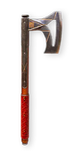](https://lord-of-the-rings-return-to-moria.fandom.com/wiki/Steel_War_Axe)

[Steel War Axe](https://lord-of-the-rings-return-to-moria.fandom.com/wiki/Steel_War_Axe)

[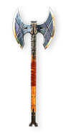](https://lord-of-the-rings-return-to-moria.fandom.com/wiki/First_Age_Battleaxe)

[First Age Battleaxe](https://lord-of-the-rings-return-to-moria.fandom.com/wiki/First_Age_Battleaxe)

[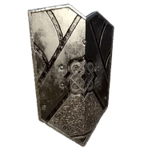](https://lord-of-the-rings-return-to-moria.fandom.com/wiki/Iron_Hills_Shield)

[Iron Hills Shield](https://lord-of-the-rings-return-to-moria.fandom.com/wiki/Iron_Hills_Shield)

[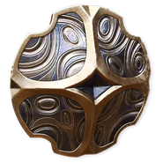](https://lord-of-the-rings-return-to-moria.fandom.com/wiki/Heirloom_Shield)

[Heirloom Shield](https://lord-of-the-rings-return-to-moria.fandom.com/wiki/Heirloom_Shield)

[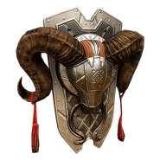](https://lord-of-the-rings-return-to-moria.fandom.com/wiki/Ram%27s_Head_Shield)

[Ram's Head Shield](https://lord-of-the-rings-return-to-moria.fandom.com/wiki/Ram%27s_Head_Shield)

[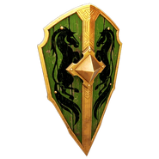](https://lord-of-the-rings-return-to-moria.fandom.com/wiki/Rohirrim_Shield)

[Rohirrim Shield](https://lord-of-the-rings-return-to-moria.fandom.com/wiki/Rohirrim_Shield)

[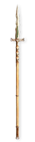](https://lord-of-the-rings-return-to-moria.fandom.com/wiki/Eregion_Spear)

[Eregion Spear](https://lord-of-the-rings-return-to-moria.fandom.com/wiki/Eregion_Spear)

[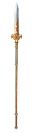](https://lord-of-the-rings-return-to-moria.fandom.com/wiki/Rohirrim_Spear)

[Rohirrim Spear](https://lord-of-the-rings-return-to-moria.fandom.com/wiki/Rohirrim_Spear)

[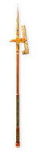](https://lord-of-the-rings-return-to-moria.fandom.com/wiki/Belegost_Halberd)

[Belegost Halberd](https://lord-of-the-rings-return-to-moria.fandom.com/wiki/Belegost_Halberd)

[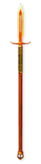](https://lord-of-the-rings-return-to-moria.fandom.com/wiki/Dimrill_Spear)

[Dimrill Spear](https://lord-of-the-rings-return-to-moria.fandom.com/wiki/Dimrill_Spear)

[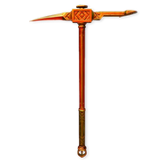](https://lord-of-the-rings-return-to-moria.fandom.com/wiki/Khaz%C3%A2d_War_Mattock)

[Khazâd War Mattock](https://lord-of-the-rings-return-to-moria.fandom.com/wiki/Khaz%C3%A2d_War_Mattock)

[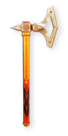](https://lord-of-the-rings-return-to-moria.fandom.com/wiki/Belegost_War_Axe)

[Belegost War Axe](https://lord-of-the-rings-return-to-moria.fandom.com/wiki/Belegost_War_Axe)

[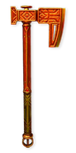](https://lord-of-the-rings-return-to-moria.fandom.com/wiki/Khaz%C3%A2d_War_Axe)

[Khazâd War Axe](https://lord-of-the-rings-return-to-moria.fandom.com/wiki/Khaz%C3%A2d_War_Axe)

[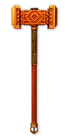](https://lord-of-the-rings-return-to-moria.fandom.com/wiki/Khaz%C3%A2d_Maul)

[Khazâd Maul](https://lord-of-the-rings-return-to-moria.fandom.com/wiki/Khaz%C3%A2d_Maul)

[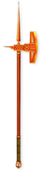](https://lord-of-the-rings-return-to-moria.fandom.com/wiki/Khaz%C3%A2d_Army_Halberd)

[Khazâd Army Halberd](https://lord-of-the-rings-return-to-moria.fandom.com/wiki/Khaz%C3%A2d_Army_Halberd)

[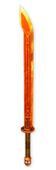](https://lord-of-the-rings-return-to-moria.fandom.com/wiki/Khaz%C3%A2d_Army_Greatsword)

[Khazâd Army Greatsword](https://lord-of-the-rings-return-to-moria.fandom.com/wiki/Khaz%C3%A2d_Army_Greatsword)

[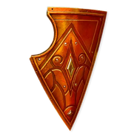](https://lord-of-the-rings-return-to-moria.fandom.com/wiki/Eregion_Shield)

[Eregion Shield](https://lord-of-the-rings-return-to-moria.fandom.com/wiki/Eregion_Shield)

[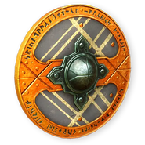](https://lord-of-the-rings-return-to-moria.fandom.com/wiki/Belegost_Shield)

[Belegost Shield](https://lord-of-the-rings-return-to-moria.fandom.com/wiki/Belegost_Shield)

[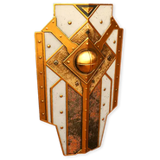](https://lord-of-the-rings-return-to-moria.fandom.com/wiki/Shieldwall)

[Shieldwall](https://lord-of-the-rings-return-to-moria.fandom.com/wiki/Shieldwall)

[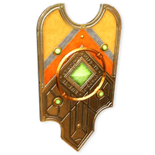](https://lord-of-the-rings-return-to-moria.fandom.com/wiki/Mithril_Shield)

[Mithril Shield](https://lord-of-the-rings-return-to-moria.fandom.com/wiki/Mithril_Shield)

[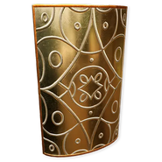](https://lord-of-the-rings-return-to-moria.fandom.com/wiki/Ornamental_Shield)

[Ornamental Shield](https://lord-of-the-rings-return-to-moria.fandom.com/wiki/Ornamental_Shield)

[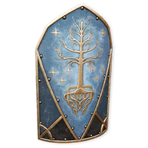](https://lord-of-the-rings-return-to-moria.fandom.com/wiki/Gondorian_Shield)

[Gondorian Shield](https://lord-of-the-rings-return-to-moria.fandom.com/wiki/Gondorian_Shield)

[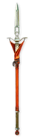](https://lord-of-the-rings-return-to-moria.fandom.com/wiki/Shaz%27akhnaman)

[Shaz'akhnaman](https://lord-of-the-rings-return-to-moria.fandom.com/wiki/Shaz%27akhnaman)

[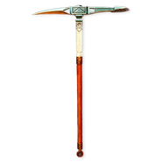](https://lord-of-the-rings-return-to-moria.fandom.com/wiki/Sagr%C3%BBris%C3%A2bun)

[Sagrûrisâbun](https://lord-of-the-rings-return-to-moria.fandom.com/wiki/Sagr%C3%BBris%C3%A2bun)

[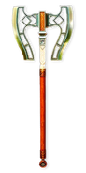](https://lord-of-the-rings-return-to-moria.fandom.com/wiki/Bar%C3%B4kamlut)

[Barôkamlut](https://lord-of-the-rings-return-to-moria.fandom.com/wiki/Bar%C3%B4kamlut)

[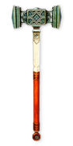](https://lord-of-the-rings-return-to-moria.fandom.com/wiki/Muasgadn%C3%BBr)

[Muasgadnûr](https://lord-of-the-rings-return-to-moria.fandom.com/wiki/Muasgadn%C3%BBr)

[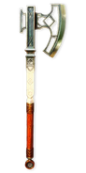](https://lord-of-the-rings-return-to-moria.fandom.com/wiki/Khushnabrak)

[Khushnabrak](https://lord-of-the-rings-return-to-moria.fandom.com/wiki/Khushnabrak)

[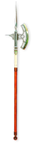](https://lord-of-the-rings-return-to-moria.fandom.com/wiki/Lafarn%C3%AEz%C3%AEn)

[Lafarnîzîn](https://lord-of-the-rings-return-to-moria.fandom.com/wiki/Lafarn%C3%AEz%C3%AEn)

[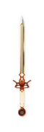](https://lord-of-the-rings-return-to-moria.fandom.com/wiki/Rukhnaman)

[Rukhnaman](https://lord-of-the-rings-return-to-moria.fandom.com/wiki/Rukhnaman)

[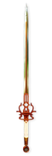](https://lord-of-the-rings-return-to-moria.fandom.com/wiki/Thanazbad)

[Thanazbad](https://lord-of-the-rings-return-to-moria.fandom.com/wiki/Thanazbad)

[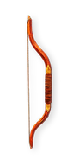](https://lord-of-the-rings-return-to-moria.fandom.com/wiki/Hunting_Bow)

[Hunting Bow](https://lord-of-the-rings-return-to-moria.fandom.com/wiki/Hunting_Bow)

[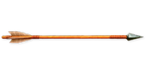](https://lord-of-the-rings-return-to-moria.fandom.com/wiki/Arrows)

[Arrows](https://lord-of-the-rings-return-to-moria.fandom.com/wiki/Arrows)

[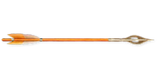](https://lord-of-the-rings-return-to-moria.fandom.com/wiki/Elven_Arrows)

[Elven Arrows](https://lord-of-the-rings-return-to-moria.fandom.com/wiki/Elven_Arrows)

[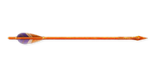](https://lord-of-the-rings-return-to-moria.fandom.com/wiki/Khaz%C3%A2d_Arrows)

[Khazâd Arrows](https://lord-of-the-rings-return-to-moria.fandom.com/wiki/Khaz%C3%A2d_Arrows)

[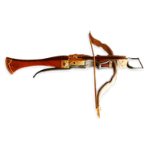](https://lord-of-the-rings-return-to-moria.fandom.com/wiki/First_Age_Crossbow)

[First Age Crossbow](https://lord-of-the-rings-return-to-moria.fandom.com/wiki/First_Age_Crossbow)

[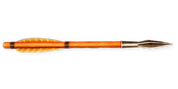](https://lord-of-the-rings-return-to-moria.fandom.com/wiki/First_Age_Bolts)

[First Age Bolts](https://lord-of-the-rings-return-to-moria.fandom.com/wiki/First_Age_Bolts)

[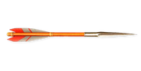](https://lord-of-the-rings-return-to-moria.fandom.com/wiki/Khaz%C3%A2d_Bolts)

[Khazâd Bolts](https://lord-of-the-rings-return-to-moria.fandom.com/wiki/Khaz%C3%A2d_Bolts)

[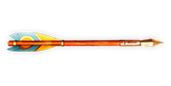](https://lord-of-the-rings-return-to-moria.fandom.com/wiki/Nogrod_Bolts)

[Nogrod Bolts](https://lord-of-the-rings-return-to-moria.fandom.com/wiki/Nogrod_Bolts)

[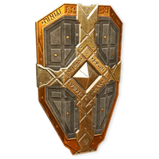](https://lord-of-the-rings-return-to-moria.fandom.com/wiki/Last_Alliance_Shield)

[Last Alliance Shield](https://lord-of-the-rings-return-to-moria.fandom.com/wiki/Last_Alliance_Shield)

[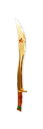](https://lord-of-the-rings-return-to-moria.fandom.com/wiki/Dagamarth)

[Dagamarth](https://lord-of-the-rings-return-to-moria.fandom.com/wiki/Dagamarth)

[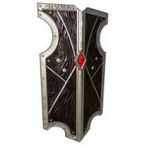](https://lord-of-the-rings-return-to-moria.fandom.com/wiki/Durin%27s_Guard_Shield)

[Durin's Guard Shield](https://lord-of-the-rings-return-to-moria.fandom.com/wiki/Durin%27s_Guard_Shield)

[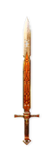](https://lord-of-the-rings-return-to-moria.fandom.com/wiki/Red_Sword_of_Nogrod)

[Red Sword of Nogrod](https://lord-of-the-rings-return-to-moria.fandom.com/wiki/Red_Sword_of_Nogrod)

[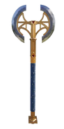](https://lord-of-the-rings-return-to-moria.fandom.com/wiki/Red_Axe_of_Nogrod)

[Red Axe of Nogrod](https://lord-of-the-rings-return-to-moria.fandom.com/wiki/Red_Axe_of_Nogrod)

[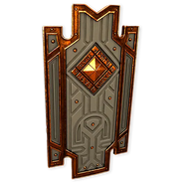](https://lord-of-the-rings-return-to-moria.fandom.com/wiki/Nogrod_Shield)

[Nogrod Shield](https://lord-of-the-rings-return-to-moria.fandom.com/wiki/Nogrod_Shield)

Advertisement

Armor

[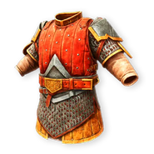](https://lord-of-the-rings-return-to-moria.fandom.com/wiki/Iron_Hills_Armor)

[Iron Hills Armor](https://lord-of-the-rings-return-to-moria.fandom.com/wiki/Iron_Hills_Armor)

[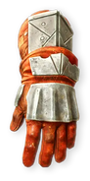](https://lord-of-the-rings-return-to-moria.fandom.com/wiki/Iron_Hills_Gloves)

[Iron Hills Gloves](https://lord-of-the-rings-return-to-moria.fandom.com/wiki/Iron_Hills_Gloves)

[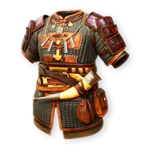](https://lord-of-the-rings-return-to-moria.fandom.com/wiki/Erebor_Ringmail)

[Erebor Ringmail](https://lord-of-the-rings-return-to-moria.fandom.com/wiki/Erebor_Ringmail)

[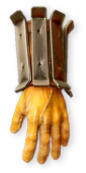](https://lord-of-the-rings-return-to-moria.fandom.com/wiki/Erebor_Planked_Gauntlets)

[Erebor Planked Gauntlets](https://lord-of-the-rings-return-to-moria.fandom.com/wiki/Erebor_Planked_Gauntlets)

[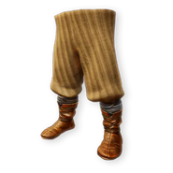](https://lord-of-the-rings-return-to-moria.fandom.com/wiki/Erebor_Boots)

[Erebor Boots](https://lord-of-the-rings-return-to-moria.fandom.com/wiki/Erebor_Boots)

[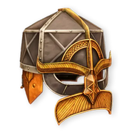](https://lord-of-the-rings-return-to-moria.fandom.com/wiki/Erebor_City_Watch_Helmet)

[Erebor City Watch Helmet](https://lord-of-the-rings-return-to-moria.fandom.com/wiki/Erebor_City_Watch_Helmet)

[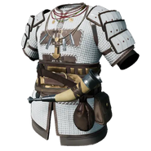](https://lord-of-the-rings-return-to-moria.fandom.com/wiki/Erebor_Ringmail_Shayar)

[Erebor Ringmail Shayar](https://lord-of-the-rings-return-to-moria.fandom.com/wiki/Erebor_Ringmail_Shayar)

[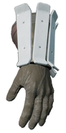](https://lord-of-the-rings-return-to-moria.fandom.com/wiki/Erebor_Planked_Gauntlets_Shayar)

[Erebor Planked Gauntlets Shayar](https://lord-of-the-rings-return-to-moria.fandom.com/wiki/Erebor_Planked_Gauntlets_Shayar)

[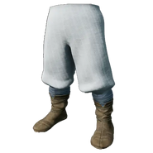](https://lord-of-the-rings-return-to-moria.fandom.com/wiki/Erebor_Boots_Shayar)

[Erebor Boots Shayar](https://lord-of-the-rings-return-to-moria.fandom.com/wiki/Erebor_Boots_Shayar)

[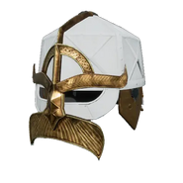](https://lord-of-the-rings-return-to-moria.fandom.com/wiki/Erebor_City_Watch_Helmet_Shayar)

[Erebor City Watch Helmet Shayar](https://lord-of-the-rings-return-to-moria.fandom.com/wiki/Erebor_City_Watch_Helmet_Shayar)

[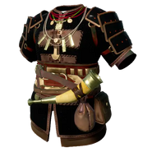](https://lord-of-the-rings-return-to-moria.fandom.com/wiki/Erebor_Ringmail_Masharuz)

[Erebor Ringmail Masharuz](https://lord-of-the-rings-return-to-moria.fandom.com/wiki/Erebor_Ringmail_Masharuz)

[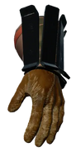](https://lord-of-the-rings-return-to-moria.fandom.com/wiki/Erebor_Planked_Gauntlets_Masharuz)

[Erebor Planked Gauntlets Masharuz](https://lord-of-the-rings-return-to-moria.fandom.com/wiki/Erebor_Planked_Gauntlets_Masharuz)

[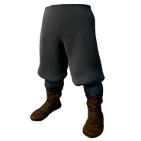](https://lord-of-the-rings-return-to-moria.fandom.com/wiki/Erebor_Boots_Masharuz)

[Erebor Boots Masharuz](https://lord-of-the-rings-return-to-moria.fandom.com/wiki/Erebor_Boots_Masharuz)

[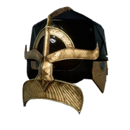](https://lord-of-the-rings-return-to-moria.fandom.com/wiki/Erebor_City_Watch_Helmet_Masharuz)

[Erebor City Watch Helmet Masharuz](https://lord-of-the-rings-return-to-moria.fandom.com/wiki/Erebor_City_Watch_Helmet_Masharuz)

[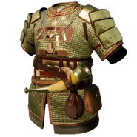](https://lord-of-the-rings-return-to-moria.fandom.com/wiki/Erebor_Ringmail_Amzul)

[Erebor Ringmail Amzul](https://lord-of-the-rings-return-to-moria.fandom.com/wiki/Erebor_Ringmail_Amzul)

[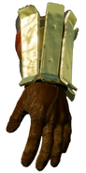](https://lord-of-the-rings-return-to-moria.fandom.com/wiki/Erebor_Planked_Gauntlets_Amzul)

[Erebor Planked Gauntlets Amzul](https://lord-of-the-rings-return-to-moria.fandom.com/wiki/Erebor_Planked_Gauntlets_Amzul)

[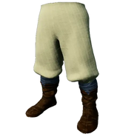](https://lord-of-the-rings-return-to-moria.fandom.com/wiki/Erebor_Boots_Amzul)

[Erebor Boots Amzul](https://lord-of-the-rings-return-to-moria.fandom.com/wiki/Erebor_Boots_Amzul)

[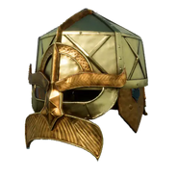](https://lord-of-the-rings-return-to-moria.fandom.com/wiki/Erebor_City_Watch_Helmet_Amzul)

[Erebor City Watch Helmet Amzul](https://lord-of-the-rings-return-to-moria.fandom.com/wiki/Erebor_City_Watch_Helmet_Amzul)

[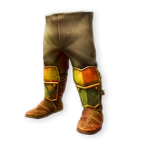](https://lord-of-the-rings-return-to-moria.fandom.com/wiki/Belegost_Boots)

[Belegost Boots](https://lord-of-the-rings-return-to-moria.fandom.com/wiki/Belegost_Boots)

[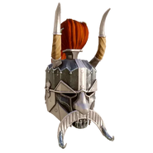](https://lord-of-the-rings-return-to-moria.fandom.com/wiki/Belegost_Helmet)

[Belegost Helmet](https://lord-of-the-rings-return-to-moria.fandom.com/wiki/Belegost_Helmet)

[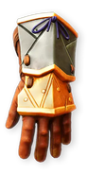](https://lord-of-the-rings-return-to-moria.fandom.com/wiki/Belegost_Gauntlets)

[Belegost Gauntlets](https://lord-of-the-rings-return-to-moria.fandom.com/wiki/Belegost_Gauntlets)

[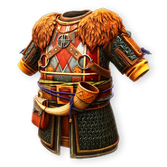](https://lord-of-the-rings-return-to-moria.fandom.com/wiki/Belegost_Ringmail)

[Belegost Ringmail](https://lord-of-the-rings-return-to-moria.fandom.com/wiki/Belegost_Ringmail)

[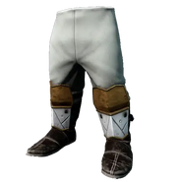](https://lord-of-the-rings-return-to-moria.fandom.com/wiki/Belegost_Boots_Shayar)

[Belegost Boots Shayar](https://lord-of-the-rings-return-to-moria.fandom.com/wiki/Belegost_Boots_Shayar)

[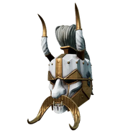](https://lord-of-the-rings-return-to-moria.fandom.com/wiki/Belegost_Helmet_Shayar)

[Belegost Helmet Shayar](https://lord-of-the-rings-return-to-moria.fandom.com/wiki/Belegost_Helmet_Shayar)

[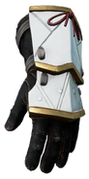](https://lord-of-the-rings-return-to-moria.fandom.com/wiki/Belegost_Gauntlets_Shayar)

[Belegost Gauntlets Shayar](https://lord-of-the-rings-return-to-moria.fandom.com/wiki/Belegost_Gauntlets_Shayar)

[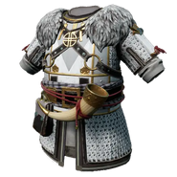](https://lord-of-the-rings-return-to-moria.fandom.com/wiki/Belegost_Ringmail_Shayar)

[Belegost Ringmail Shayar](https://lord-of-the-rings-return-to-moria.fandom.com/wiki/Belegost_Ringmail_Shayar)

[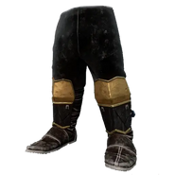](https://lord-of-the-rings-return-to-moria.fandom.com/wiki/Belegost_Boots_Masharuz)

[Belegost Boots Masharuz](https://lord-of-the-rings-return-to-moria.fandom.com/wiki/Belegost_Boots_Masharuz)

[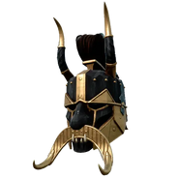](https://lord-of-the-rings-return-to-moria.fandom.com/wiki/Belegost_Helmet_Masharuz)

[Belegost Helmet Masharuz](https://lord-of-the-rings-return-to-moria.fandom.com/wiki/Belegost_Helmet_Masharuz)

[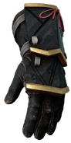](https://lord-of-the-rings-return-to-moria.fandom.com/wiki/Belegost_Gauntlets_Masharuz)

[Belegost Gauntlets Masharuz](https://lord-of-the-rings-return-to-moria.fandom.com/wiki/Belegost_Gauntlets_Masharuz)

[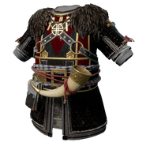](https://lord-of-the-rings-return-to-moria.fandom.com/wiki/Belegost_Ringmail_Masharuz)

[Belegost Ringmail Masharuz](https://lord-of-the-rings-return-to-moria.fandom.com/wiki/Belegost_Ringmail_Masharuz)

[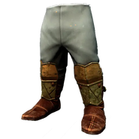](https://lord-of-the-rings-return-to-moria.fandom.com/wiki/Belegost_Boots_Amzul)

[Belegost Boots Amzul](https://lord-of-the-rings-return-to-moria.fandom.com/wiki/Belegost_Boots_Amzul)

[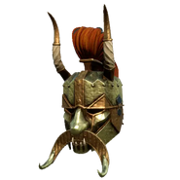](https://lord-of-the-rings-return-to-moria.fandom.com/wiki/Belegost_Helmet_Amzul)

[Belegost Helmet Amzul](https://lord-of-the-rings-return-to-moria.fandom.com/wiki/Belegost_Helmet_Amzul)

[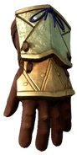](https://lord-of-the-rings-return-to-moria.fandom.com/wiki/Belegost_Gauntlets_Amzul)

[Belegost Gauntlets Amzul](https://lord-of-the-rings-return-to-moria.fandom.com/wiki/Belegost_Gauntlets_Amzul)

[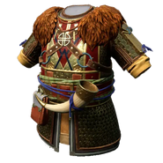](https://lord-of-the-rings-return-to-moria.fandom.com/wiki/Belegost_Ringmail_Amzul)

[Belegost Ringmail Amzul](https://lord-of-the-rings-return-to-moria.fandom.com/wiki/Belegost_Ringmail_Amzul)

[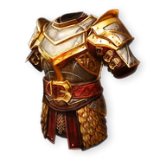](https://lord-of-the-rings-return-to-moria.fandom.com/wiki/Khaz%C3%A2d_Army_Armor)

[Khazâd Army Armor](https://lord-of-the-rings-return-to-moria.fandom.com/wiki/Khaz%C3%A2d_Army_Armor)

[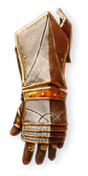](https://lord-of-the-rings-return-to-moria.fandom.com/wiki/Khaz%C3%A2d_Army_Gauntlets)

[Khazâd Army Gauntlets](https://lord-of-the-rings-return-to-moria.fandom.com/wiki/Khaz%C3%A2d_Army_Gauntlets)

[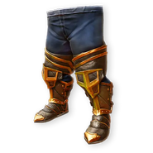](https://lord-of-the-rings-return-to-moria.fandom.com/wiki/Khaz%C3%A2d_Army_Boots)

[Khazâd Army Boots](https://lord-of-the-rings-return-to-moria.fandom.com/wiki/Khaz%C3%A2d_Army_Boots)

[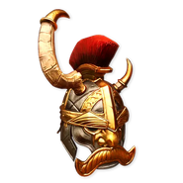](https://lord-of-the-rings-return-to-moria.fandom.com/wiki/Khaz%C3%A2d_Army_Helmet)

[Khazâd Army Helmet](https://lord-of-the-rings-return-to-moria.fandom.com/wiki/Khaz%C3%A2d_Army_Helmet)

[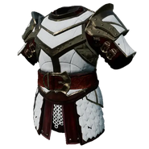](https://lord-of-the-rings-return-to-moria.fandom.com/wiki/Khaz%C3%A2d_Army_Armor_Shayar)

[Khazâd Army Armor Shayar](https://lord-of-the-rings-return-to-moria.fandom.com/wiki/Khaz%C3%A2d_Army_Armor_Shayar)

[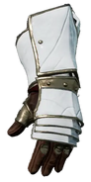](https://lord-of-the-rings-return-to-moria.fandom.com/wiki/Khaz%C3%A2d_Army_Gauntlets_Shayar)

[Khazâd Army Gauntlets Shayar](https://lord-of-the-rings-return-to-moria.fandom.com/wiki/Khaz%C3%A2d_Army_Gauntlets_Shayar)

[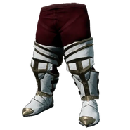](https://lord-of-the-rings-return-to-moria.fandom.com/wiki/Khaz%C3%A2d_Army_Boots_Shayar)

[Khazâd Army Boots Shayar](https://lord-of-the-rings-return-to-moria.fandom.com/wiki/Khaz%C3%A2d_Army_Boots_Shayar)

[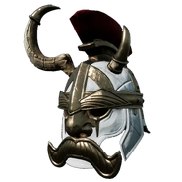](https://lord-of-the-rings-return-to-moria.fandom.com/wiki/Khaz%C3%A2d_Army_Helmet_Shayar)

[Khazâd Army Helmet Shayar](https://lord-of-the-rings-return-to-moria.fandom.com/wiki/Khaz%C3%A2d_Army_Helmet_Shayar)

[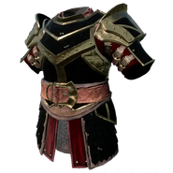](https://lord-of-the-rings-return-to-moria.fandom.com/wiki/Khaz%C3%A2d_Army_Armor_Masharuz)

[Khazâd Army Armor Masharuz](https://lord-of-the-rings-return-to-moria.fandom.com/wiki/Khaz%C3%A2d_Army_Armor_Masharuz)

[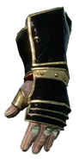](https://lord-of-the-rings-return-to-moria.fandom.com/wiki/Khaz%C3%A2d_Army_Gauntlets_Masharuz)

[Khazâd Army Gauntlets Masharuz](https://lord-of-the-rings-return-to-moria.fandom.com/wiki/Khaz%C3%A2d_Army_Gauntlets_Masharuz)

[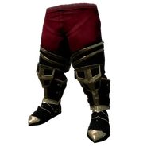](https://lord-of-the-rings-return-to-moria.fandom.com/wiki/Khaz%C3%A2d_Army_Boots_Masharuz)

[Khazâd Army Boots Masharuz](https://lord-of-the-rings-return-to-moria.fandom.com/wiki/Khaz%C3%A2d_Army_Boots_Masharuz)

[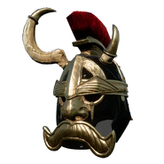](https://lord-of-the-rings-return-to-moria.fandom.com/wiki/Khaz%C3%A2d_Army_Helmet_Masharuz)

[Khazâd Army Helmet Masharuz](https://lord-of-the-rings-return-to-moria.fandom.com/wiki/Khaz%C3%A2d_Army_Helmet_Masharuz)

[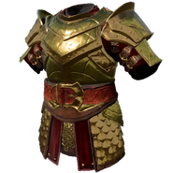](https://lord-of-the-rings-return-to-moria.fandom.com/wiki/Khaz%C3%A2d_Army_Armor_Amzul)

[Khazâd Army Armor Amzul](https://lord-of-the-rings-return-to-moria.fandom.com/wiki/Khaz%C3%A2d_Army_Armor_Amzul)

[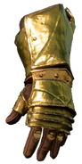](https://lord-of-the-rings-return-to-moria.fandom.com/wiki/Khaz%C3%A2d_Army_Gauntlets_Amzul)

[Khazâd Army Gauntlets Amzul](https://lord-of-the-rings-return-to-moria.fandom.com/wiki/Khaz%C3%A2d_Army_Gauntlets_Amzul)

[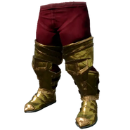](https://lord-of-the-rings-return-to-moria.fandom.com/wiki/Khaz%C3%A2d_Army_Boots_Amzul)

[Khazâd Army Boots Amzul](https://lord-of-the-rings-return-to-moria.fandom.com/wiki/Khaz%C3%A2d_Army_Boots_Amzul)

[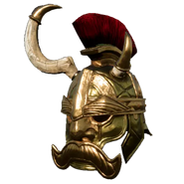](https://lord-of-the-rings-return-to-moria.fandom.com/wiki/Khaz%C3%A2d_Army_Helmet_Amzul)

[Khazâd Army Helmet Amzul](https://lord-of-the-rings-return-to-moria.fandom.com/wiki/Khaz%C3%A2d_Army_Helmet_Amzul)

[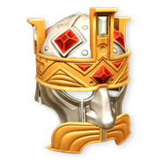](https://lord-of-the-rings-return-to-moria.fandom.com/wiki/Mithril_Helmet)

[Mithril Helmet](https://lord-of-the-rings-return-to-moria.fandom.com/wiki/Mithril_Helmet)

[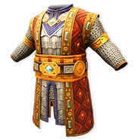](https://lord-of-the-rings-return-to-moria.fandom.com/wiki/Mithril_Armor)

[Mithril Armor](https://lord-of-the-rings-return-to-moria.fandom.com/wiki/Mithril_Armor)

[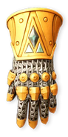](https://lord-of-the-rings-return-to-moria.fandom.com/wiki/Mithril_Gloves)

[Mithril Gloves](https://lord-of-the-rings-return-to-moria.fandom.com/wiki/Mithril_Gloves)

[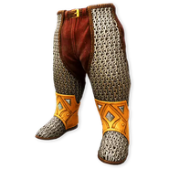](https://lord-of-the-rings-return-to-moria.fandom.com/wiki/Mithril_Slippers)

[Mithril Slippers](https://lord-of-the-rings-return-to-moria.fandom.com/wiki/Mithril_Slippers)

[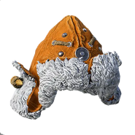](https://lord-of-the-rings-return-to-moria.fandom.com/wiki/Trapper_Hat)

[Trapper Hat](https://lord-of-the-rings-return-to-moria.fandom.com/wiki/Trapper_Hat)

[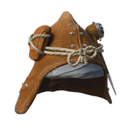](https://lord-of-the-rings-return-to-moria.fandom.com/wiki/Longbottom_Hat)

[Longbottom Hat](https://lord-of-the-rings-return-to-moria.fandom.com/wiki/Longbottom_Hat)

[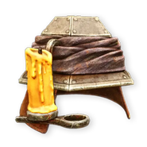](https://lord-of-the-rings-return-to-moria.fandom.com/wiki/Miner%27s_Helmet)

[Miner's Helmet](https://lord-of-the-rings-return-to-moria.fandom.com/wiki/Miner%27s_Helmet)

[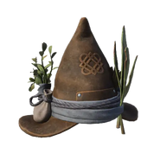](https://lord-of-the-rings-return-to-moria.fandom.com/wiki/Gatherer%27s_Hat)

[Gatherer's Hat](https://lord-of-the-rings-return-to-moria.fandom.com/wiki/Gatherer%27s_Hat)

[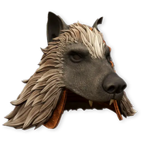](https://lord-of-the-rings-return-to-moria.fandom.com/wiki/Wolf_Skin_Hat)

[Wolf Skin Hat](https://lord-of-the-rings-return-to-moria.fandom.com/wiki/Wolf_Skin_Hat)

[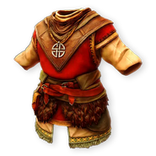](https://lord-of-the-rings-return-to-moria.fandom.com/wiki/Blue_Mountains_Hunter%27s_Armor)

[Blue Mountains Hunter's Armor](https://lord-of-the-rings-return-to-moria.fandom.com/wiki/Blue_Mountains_Hunter%27s_Armor)

[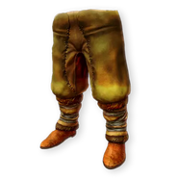](https://lord-of-the-rings-return-to-moria.fandom.com/wiki/Blue_Mountains_Hunter%27s_Boots)

[Blue Mountains Hunter's Boots](https://lord-of-the-rings-return-to-moria.fandom.com/wiki/Blue_Mountains_Hunter%27s_Boots)

[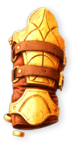](https://lord-of-the-rings-return-to-moria.fandom.com/wiki/Blue_Mountains_Hunter%27s_Gloves)

[Blue Mountains Hunter's Gloves](https://lord-of-the-rings-return-to-moria.fandom.com/wiki/Blue_Mountains_Hunter%27s_Gloves)

[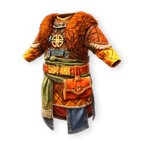](https://lord-of-the-rings-return-to-moria.fandom.com/wiki/Grey_Mountain_Overcoat)

[Grey Mountain Overcoat](https://lord-of-the-rings-return-to-moria.fandom.com/wiki/Grey_Mountain_Overcoat)

[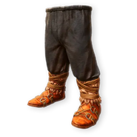](https://lord-of-the-rings-return-to-moria.fandom.com/wiki/Grey_Mountains_Boots)

[Grey Mountains Boots](https://lord-of-the-rings-return-to-moria.fandom.com/wiki/Grey_Mountains_Boots)

[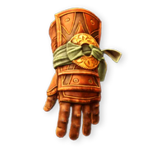](https://lord-of-the-rings-return-to-moria.fandom.com/wiki/Grey_Mountain_Gloves)

[Grey Mountain Gloves](https://lord-of-the-rings-return-to-moria.fandom.com/wiki/Grey_Mountain_Gloves)

[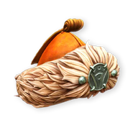](https://lord-of-the-rings-return-to-moria.fandom.com/wiki/Grey_Mountain_Hat)

[Grey Mountain Hat](https://lord-of-the-rings-return-to-moria.fandom.com/wiki/Grey_Mountain_Hat)

[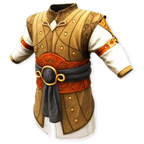](https://lord-of-the-rings-return-to-moria.fandom.com/wiki/Eregion_Armor)

[Eregion Armor](https://lord-of-the-rings-return-to-moria.fandom.com/wiki/Eregion_Armor)

[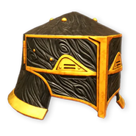](https://lord-of-the-rings-return-to-moria.fandom.com/wiki/Durin%27s_Guard_Helmet)

[Durin's Guard Helmet](https://lord-of-the-rings-return-to-moria.fandom.com/wiki/Durin%27s_Guard_Helmet)

[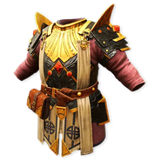](https://lord-of-the-rings-return-to-moria.fandom.com/wiki/Durin%27s_Guard_Armor)

[Durin's Guard Armor](https://lord-of-the-rings-return-to-moria.fandom.com/wiki/Durin%27s_Guard_Armor)

[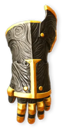](https://lord-of-the-rings-return-to-moria.fandom.com/wiki/Durin%27s_Gloves)

[Durin's Gloves](https://lord-of-the-rings-return-to-moria.fandom.com/wiki/Durin%27s_Gloves)

[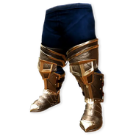](https://lord-of-the-rings-return-to-moria.fandom.com/wiki/Durin%27s_Guard_Boots)

[Durin's Guard Boots](https://lord-of-the-rings-return-to-moria.fandom.com/wiki/Durin%27s_Guard_Boots)

[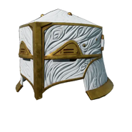](https://lord-of-the-rings-return-to-moria.fandom.com/wiki/Durin%27s_Guard_Helmet_Shayar)

[Durin's Guard Helmet Shayar](https://lord-of-the-rings-return-to-moria.fandom.com/wiki/Durin%27s_Guard_Helmet_Shayar)

[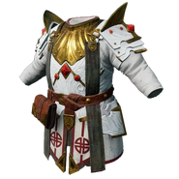](https://lord-of-the-rings-return-to-moria.fandom.com/wiki/Durin%27s_Guard_Armor_Shayar)

[Durin's Guard Armor Shayar](https://lord-of-the-rings-return-to-moria.fandom.com/wiki/Durin%27s_Guard_Armor_Shayar)

[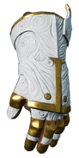](https://lord-of-the-rings-return-to-moria.fandom.com/wiki/Durin%27s_Gloves_Shayar)

[Durin's Gloves Shayar](https://lord-of-the-rings-return-to-moria.fandom.com/wiki/Durin%27s_Gloves_Shayar)

[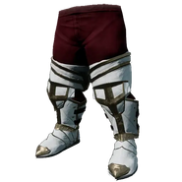](https://lord-of-the-rings-return-to-moria.fandom.com/wiki/Durin%27s_Guard_Boots_Shayar)

[Durin's Guard Boots Shayar](https://lord-of-the-rings-return-to-moria.fandom.com/wiki/Durin%27s_Guard_Boots_Shayar)

[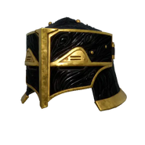](https://lord-of-the-rings-return-to-moria.fandom.com/wiki/Durin%27s_Guard_Helmet_Masharuz)

[Durin's Guard Helmet Masharuz](https://lord-of-the-rings-return-to-moria.fandom.com/wiki/Durin%27s_Guard_Helmet_Masharuz)

[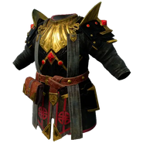](https://lord-of-the-rings-return-to-moria.fandom.com/wiki/Durin%27s_Guard_Armor_Masharuz)

[Durin's Guard Armor Masharuz](https://lord-of-the-rings-return-to-moria.fandom.com/wiki/Durin%27s_Guard_Armor_Masharuz)

[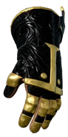](https://lord-of-the-rings-return-to-moria.fandom.com/wiki/Durin%27s_Gloves_Masharuz)

[Durin's Gloves Masharuz](https://lord-of-the-rings-return-to-moria.fandom.com/wiki/Durin%27s_Gloves_Masharuz)

[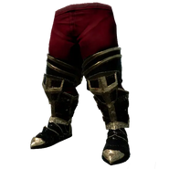](https://lord-of-the-rings-return-to-moria.fandom.com/wiki/Durin%27s_Guard_Boots_Masharuz)

[Durin's Guard Boots Masharuz](https://lord-of-the-rings-return-to-moria.fandom.com/wiki/Durin%27s_Guard_Boots_Masharuz)

[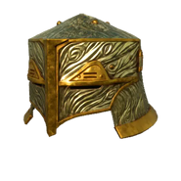](https://lord-of-the-rings-return-to-moria.fandom.com/wiki/Durin%27s_Guard_Helmet_Amzul)

[Durin's Guard Helmet Amzul](https://lord-of-the-rings-return-to-moria.fandom.com/wiki/Durin%27s_Guard_Helmet_Amzul)

[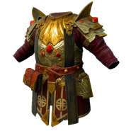](https://lord-of-the-rings-return-to-moria.fandom.com/wiki/Durin%27s_Guard_Armor_Amzul)

[Durin's Guard Armor Amzul](https://lord-of-the-rings-return-to-moria.fandom.com/wiki/Durin%27s_Guard_Armor_Amzul)

[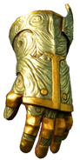](https://lord-of-the-rings-return-to-moria.fandom.com/wiki/Durin%27s_Gloves_Amzul)

[Durin's Gloves Amzul](https://lord-of-the-rings-return-to-moria.fandom.com/wiki/Durin%27s_Gloves_Amzul)

[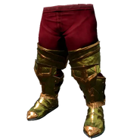](https://lord-of-the-rings-return-to-moria.fandom.com/wiki/Durin%27s_Guard_Boots_Amzul)

[Durin's Guard Boots Amzul](https://lord-of-the-rings-return-to-moria.fandom.com/wiki/Durin%27s_Guard_Boots_Amzul)

[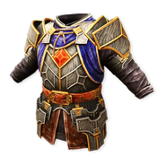](https://lord-of-the-rings-return-to-moria.fandom.com/wiki/Nogrod_Armor)

[Nogrod Armor](https://lord-of-the-rings-return-to-moria.fandom.com/wiki/Nogrod_Armor)

[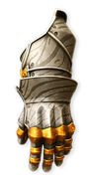](https://lord-of-the-rings-return-to-moria.fandom.com/wiki/Nogrod_Gauntlets)

[Nogrod Gauntlets](https://lord-of-the-rings-return-to-moria.fandom.com/wiki/Nogrod_Gauntlets)

Advertisement

Wardrobe

[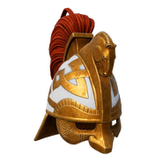](https://lord-of-the-rings-return-to-moria.fandom.com/wiki/Rohan_Helmet)

[Rohan Helmet](https://lord-of-the-rings-return-to-moria.fandom.com/wiki/Rohan_Helmet)

[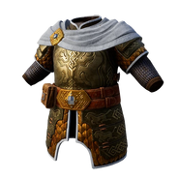](https://lord-of-the-rings-return-to-moria.fandom.com/wiki/Rohan_Armor)

[Rohan Armor](https://lord-of-the-rings-return-to-moria.fandom.com/wiki/Rohan_Armor)

[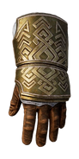](https://lord-of-the-rings-return-to-moria.fandom.com/wiki/Rohan_Gauntlets)

[Rohan Gauntlets](https://lord-of-the-rings-return-to-moria.fandom.com/wiki/Rohan_Gauntlets)

[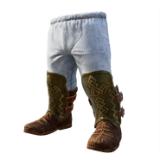](https://lord-of-the-rings-return-to-moria.fandom.com/wiki/Rohan_Boots)

[Rohan Boots](https://lord-of-the-rings-return-to-moria.fandom.com/wiki/Rohan_Boots)

[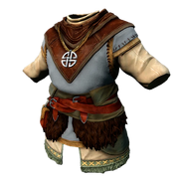](https://lord-of-the-rings-return-to-moria.fandom.com/wiki/Blue_Mountains_Outfit)

[Blue Mountains Outfit](https://lord-of-the-rings-return-to-moria.fandom.com/wiki/Blue_Mountains_Outfit)

[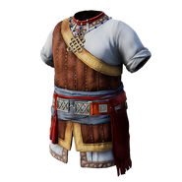](https://lord-of-the-rings-return-to-moria.fandom.com/wiki/Coastal_Mountains_Outfit)

[Coastal Mountains Outfit](https://lord-of-the-rings-return-to-moria.fandom.com/wiki/Coastal_Mountains_Outfit)

[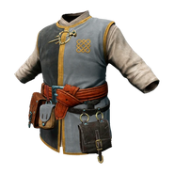](https://lord-of-the-rings-return-to-moria.fandom.com/wiki/Glittering_Caves_Outfit)

[littering Caves Outfit](https://lord-of-the-rings-return-to-moria.fandom.com/wiki/Littering_Caves_Outfit)

[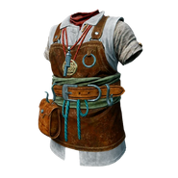](https://lord-of-the-rings-return-to-moria.fandom.com/wiki/Iron_Hills_Outfit)

[Iron Hills Outfit](https://lord-of-the-rings-return-to-moria.fandom.com/wiki/Iron_Hills_Outfit)

[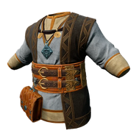](https://lord-of-the-rings-return-to-moria.fandom.com/wiki/Lonely_Mountain_Outfit)

[Lonely Mountain Outfit](https://lord-of-the-rings-return-to-moria.fandom.com/wiki/Lonely_Mountain_Outfit)

[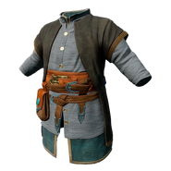](https://lord-of-the-rings-return-to-moria.fandom.com/wiki/Red_Mountain_Outfit)

[Red Mountain Outfit](https://lord-of-the-rings-return-to-moria.fandom.com/wiki/Red_Mountain_Outfit)

[[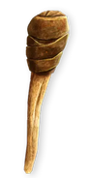](https://lord-of-the-rings-return-to-moria.fandom.com/wiki/Torch)](https://lord-of-the-rings-return-to-moria.fandom.com/wiki/Torch)

[Torch](https://lord-of-the-rings-return-to-moria.fandom.com/wiki/Torch)

[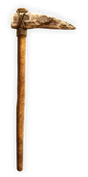](https://lord-of-the-rings-return-to-moria.fandom.com/wiki/Simple_Pickaxe)

[Simple Pickaxe](https://lord-of-the-rings-return-to-moria.fandom.com/wiki/Simple_Pickaxe)

[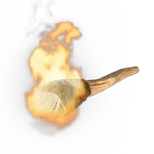](https://lord-of-the-rings-return-to-moria.fandom.com/wiki/Wood_Flare)

[Wood Flare](https://lord-of-the-rings-return-to-moria.fandom.com/wiki/Wood_Flare)

[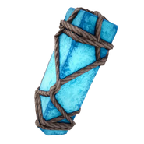](https://lord-of-the-rings-return-to-moria.fandom.com/wiki/Crystal_Flare)

[Crystal Flare](https://lord-of-the-rings-return-to-moria.fandom.com/wiki/Crystal_Flare)

[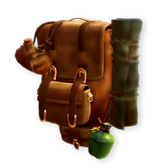](https://lord-of-the-rings-return-to-moria.fandom.com/wiki/Scout%27s_Pack)

[Scout's Pack](https://lord-of-the-rings-return-to-moria.fandom.com/wiki/Scout%27s_Pack)

[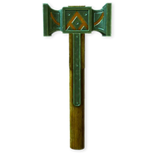](https://lord-of-the-rings-return-to-moria.fandom.com/wiki/Iron_Hammer)

[Iron Hammer](https://lord-of-the-rings-return-to-moria.fandom.com/wiki/Iron_Hammer)

[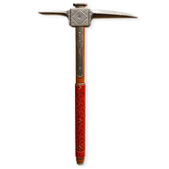](https://lord-of-the-rings-return-to-moria.fandom.com/wiki/Steel_Pickaxe)

[Steel Pickaxe](https://lord-of-the-rings-return-to-moria.fandom.com/wiki/Steel_Pickaxe)

[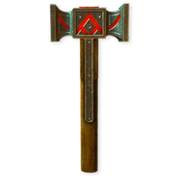](https://lord-of-the-rings-return-to-moria.fandom.com/wiki/Steel_Hammer)

[Steel Hammer](https://lord-of-the-rings-return-to-moria.fandom.com/wiki/Steel_Hammer)

[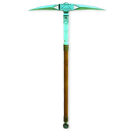](https://lord-of-the-rings-return-to-moria.fandom.com/wiki/First_Age_Pickaxe)

[First Age Pickaxe](https://lord-of-the-rings-return-to-moria.fandom.com/wiki/First_Age_Pickaxe)

[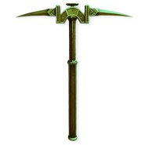](https://lord-of-the-rings-return-to-moria.fandom.com/wiki/Ironwood_Pickaxe)

[Ironwood Pickaxe](https://lord-of-the-rings-return-to-moria.fandom.com/wiki/Ironwood_Pickaxe)

[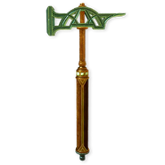](https://lord-of-the-rings-return-to-moria.fandom.com/wiki/Adamant_Hammer)

[Adamant Hammer](https://lord-of-the-rings-return-to-moria.fandom.com/wiki/Adamant_Hammer)

[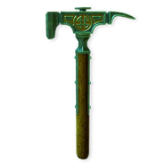](https://lord-of-the-rings-return-to-moria.fandom.com/wiki/Shan%C3%B4r_Hammer)

[Shanôr Hammer](https://lord-of-the-rings-return-to-moria.fandom.com/wiki/Shan%C3%B4r_Hammer)

[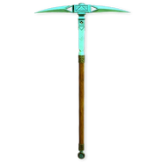](https://lord-of-the-rings-return-to-moria.fandom.com/wiki/Quarrymaster)

[Quarrymaster](https://lord-of-the-rings-return-to-moria.fandom.com/wiki/Quarrymaster)

[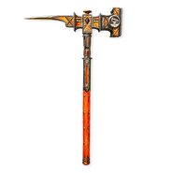](https://lord-of-the-rings-return-to-moria.fandom.com/wiki/Durin%27s_Axe)

[Durin's Axe](https://lord-of-the-rings-return-to-moria.fandom.com/wiki/Durin%27s_Axe)

[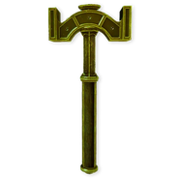](https://lord-of-the-rings-return-to-moria.fandom.com/wiki/Star-metal_Hammer)

[Star-metal Hammer](https://lord-of-the-rings-return-to-moria.fandom.com/wiki/Star-metal_Hammer)

[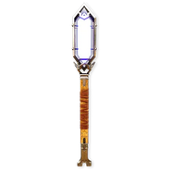](https://lord-of-the-rings-return-to-moria.fandom.com/wiki/Zar%C3%B4k_Torch)

[Zarôk Torch](https://lord-of-the-rings-return-to-moria.fandom.com/wiki/Zar%C3%B4k_Torch)

[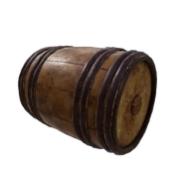](https://lord-of-the-rings-return-to-moria.fandom.com/wiki/Wanderkeg)

[Wanderkeg](https://lord-of-the-rings-return-to-moria.fandom.com/wiki/Wanderkeg)

[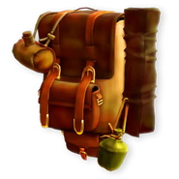](https://lord-of-the-rings-return-to-moria.fandom.com/wiki/Adventurer%27s_Pack)

[Adventurer's Pack](https://lord-of-the-rings-return-to-moria.fandom.com/wiki/Adventurer%27s_Pack)

[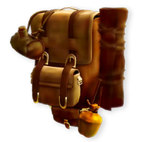](https://lord-of-the-rings-return-to-moria.fandom.com/wiki/Mountaineer%27s_Pack)

[Mountaineer's Pack](https://lord-of-the-rings-return-to-moria.fandom.com/wiki/Mountaineer%27s_Pack)

[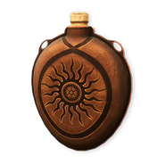](https://lord-of-the-rings-return-to-moria.fandom.com/wiki/Brewskin)

[Brewskin](https://lord-of-the-rings-return-to-moria.fandom.com/wiki/Brewskin)

Advertisement

Âbakhs

[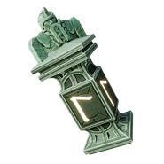](https://lord-of-the-rings-return-to-moria.fandom.com/wiki/Boost_%C3%82bakh)

[Boost Âbakh](https://lord-of-the-rings-return-to-moria.fandom.com/wiki/Boost_%C3%82bakh)

[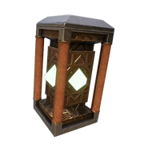](https://lord-of-the-rings-return-to-moria.fandom.com/wiki/Cleansing_%C3%82bakh)

[Cleansing Âbakh](https://lord-of-the-rings-return-to-moria.fandom.com/wiki/Cleansing_%C3%82bakh)

[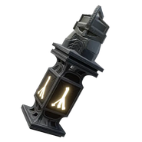](https://lord-of-the-rings-return-to-moria.fandom.com/wiki/Fury_%C3%82bakh)

[Fury Âbakh](https://lord-of-the-rings-return-to-moria.fandom.com/wiki/Fury_%C3%82bakh)

[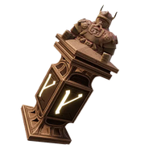](https://lord-of-the-rings-return-to-moria.fandom.com/wiki/Power_%C3%82bakh)

[Power Âbakh](https://lord-of-the-rings-return-to-moria.fandom.com/wiki/Power_%C3%82bakh)

[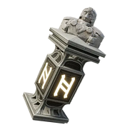](https://lord-of-the-rings-return-to-moria.fandom.com/wiki/Reflex_%C3%82bakh)

[Reflex Âbakh](https://lord-of-the-rings-return-to-moria.fandom.com/wiki/Reflex_%C3%82bakh)

[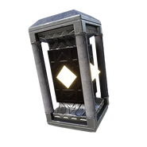](https://lord-of-the-rings-return-to-moria.fandom.com/wiki/Resolve_%C3%82bakh)

[Resolve Âbakh](https://lord-of-the-rings-return-to-moria.fandom.com/wiki/Resolve_%C3%82bakh)

[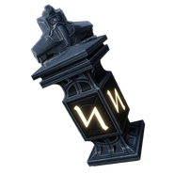](https://lord-of-the-rings-return-to-moria.fandom.com/wiki/Swift_%C3%82bakh)

[Swift Âbakh](https://lord-of-the-rings-return-to-moria.fandom.com/wiki/Swift_%C3%82bakh)

[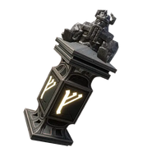](https://lord-of-the-rings-return-to-moria.fandom.com/wiki/Warding_%C3%82bakh)

[Warding Âbakh](https://lord-of-the-rings-return-to-moria.fandom.com/wiki/Warding_%C3%82bakh)

[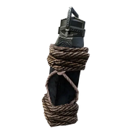](https://lord-of-the-rings-return-to-moria.fandom.com/wiki/Damaged_%C3%82bakh)

[Damaged Âbakh](https://lord-of-the-rings-return-to-moria.fandom.com/wiki/Damaged_%C3%82bakh)

Ingredients

[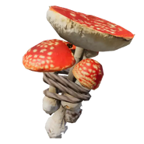](https://lord-of-the-rings-return-to-moria.fandom.com/wiki/Aberrant_Cavecaps)

[Aberrant Cavecaps](https://lord-of-the-rings-return-to-moria.fandom.com/wiki/Aberrant_Cavecaps)

[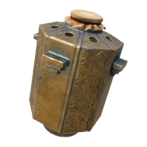](https://lord-of-the-rings-return-to-moria.fandom.com/wiki/Annuminas_Spice)

[Annuminas Spice](https://lord-of-the-rings-return-to-moria.fandom.com/wiki/Annuminas_Spice)

[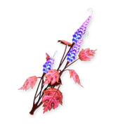](https://lord-of-the-rings-return-to-moria.fandom.com/wiki/Aul%C3%AB_Bloom)

[Aulë Bloom](https://lord-of-the-rings-return-to-moria.fandom.com/wiki/Aul%C3%AB_Bloom)

[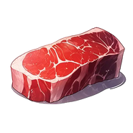](https://lord-of-the-rings-return-to-moria.fandom.com/wiki/Meat)

[Meat](https://lord-of-the-rings-return-to-moria.fandom.com/wiki/Meat)

[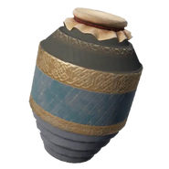](https://lord-of-the-rings-return-to-moria.fandom.com/wiki/Milled_Oats)

[Milled Oats](https://lord-of-the-rings-return-to-moria.fandom.com/wiki/Milled_Oats)

[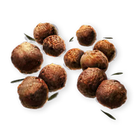](https://lord-of-the-rings-return-to-moria.fandom.com/wiki/Mint_Seed)

[Mint Seed](https://lord-of-the-rings-return-to-moria.fandom.com/wiki/Mint_Seed)

[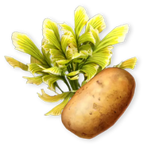](https://lord-of-the-rings-return-to-moria.fandom.com/wiki/Mountain_Potato)

[Mountain Potato](https://lord-of-the-rings-return-to-moria.fandom.com/wiki/Mountain_Potato)

[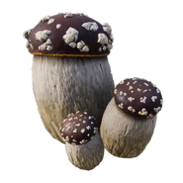](https://lord-of-the-rings-return-to-moria.fandom.com/wiki/Mushrooms)

[Mushrooms](https://lord-of-the-rings-return-to-moria.fandom.com/wiki/Mushrooms)

[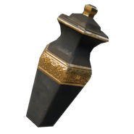](https://lord-of-the-rings-return-to-moria.fandom.com/wiki/Oat_Milk)

[Oat Milk](https://lord-of-the-rings-return-to-moria.fandom.com/wiki/Oat_Milk)

[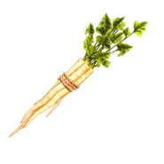](https://lord-of-the-rings-return-to-moria.fandom.com/wiki/Parsnips)

[Parsnips](https://lord-of-the-rings-return-to-moria.fandom.com/wiki/Parsnips)

[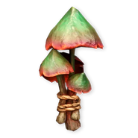](https://lord-of-the-rings-return-to-moria.fandom.com/wiki/Poison_Mushroom)

[Poison Mushroom](https://lord-of-the-rings-return-to-moria.fandom.com/wiki/Poison_Mushroom)

[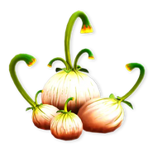](https://lord-of-the-rings-return-to-moria.fandom.com/wiki/Sunion)

[Sunion](https://lord-of-the-rings-return-to-moria.fandom.com/wiki/Sunion)

[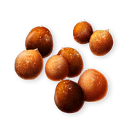](https://lord-of-the-rings-return-to-moria.fandom.com/wiki/Thyme_Seed)

[Thyme Seed](https://lord-of-the-rings-return-to-moria.fandom.com/wiki/Thyme_Seed)

[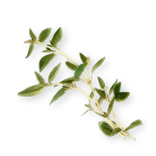](https://lord-of-the-rings-return-to-moria.fandom.com/wiki/Thyme)

[Thyme](https://lord-of-the-rings-return-to-moria.fandom.com/wiki/Thyme)

[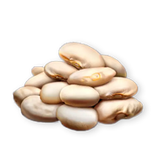](https://lord-of-the-rings-return-to-moria.fandom.com/wiki/White_Bean_Seed)

[White Bean Seed](https://lord-of-the-rings-return-to-moria.fandom.com/wiki/White_Bean_Seed)

[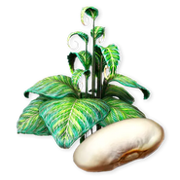](https://lord-of-the-rings-return-to-moria.fandom.com/wiki/White_Beans)

[White Beans](https://lord-of-the-rings-return-to-moria.fandom.com/wiki/White_Beans)

[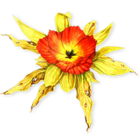](https://lord-of-the-rings-return-to-moria.fandom.com/wiki/Biteweed)

[Biteweed](https://lord-of-the-rings-return-to-moria.fandom.com/wiki/Biteweed)

[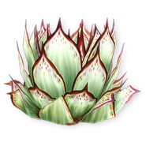](https://lord-of-the-rings-return-to-moria.fandom.com/wiki/Cabbage)

[Cabbage](https://lord-of-the-rings-return-to-moria.fandom.com/wiki/Cabbage)

[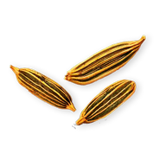](https://lord-of-the-rings-return-to-moria.fandom.com/wiki/Chive_Seed)

[Chive Seed](https://lord-of-the-rings-return-to-moria.fandom.com/wiki/Chive_Seed)

[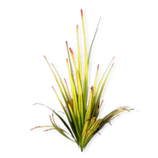](https://lord-of-the-rings-return-to-moria.fandom.com/wiki/Chives)

[Chives](https://lord-of-the-rings-return-to-moria.fandom.com/wiki/Chives)

[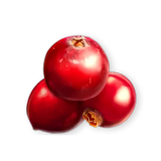](https://lord-of-the-rings-return-to-moria.fandom.com/wiki/Cranberries)

[Cranberries](https://lord-of-the-rings-return-to-moria.fandom.com/wiki/Cranberries)

[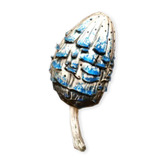](https://lord-of-the-rings-return-to-moria.fandom.com/wiki/Deep_Mushroom)

[Deep Mushroom](https://lord-of-the-rings-return-to-moria.fandom.com/wiki/Deep_Mushroom)

[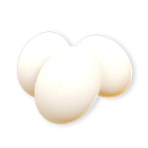](https://lord-of-the-rings-return-to-moria.fandom.com/wiki/Egg)

[Egg](https://lord-of-the-rings-return-to-moria.fandom.com/wiki/Egg)

[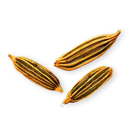](https://lord-of-the-rings-return-to-moria.fandom.com/wiki/Fennel_Seed)

[Fennel Seed](https://lord-of-the-rings-return-to-moria.fandom.com/wiki/Fennel_Seed)

[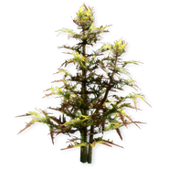](https://lord-of-the-rings-return-to-moria.fandom.com/wiki/Fennel)

[Fennel](https://lord-of-the-rings-return-to-moria.fandom.com/wiki/Fennel)

[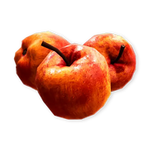](https://lord-of-the-rings-return-to-moria.fandom.com/wiki/Grabapple)

[Grabapple](https://lord-of-the-rings-return-to-moria.fandom.com/wiki/Grabapple)

[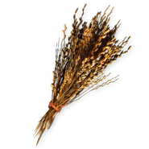](https://lord-of-the-rings-return-to-moria.fandom.com/wiki/Khuzdul_Oat)

[Khuzdul Oat](https://lord-of-the-rings-return-to-moria.fandom.com/wiki/Khuzdul_Oat)

[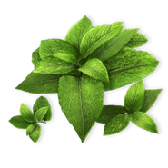](https://lord-of-the-rings-return-to-moria.fandom.com/wiki/Mint)

[Mint](https://lord-of-the-rings-return-to-moria.fandom.com/wiki/Mint)

[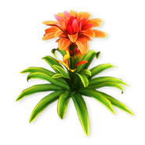](https://lord-of-the-rings-return-to-moria.fandom.com/wiki/Thanazutsam)

[Thanazutsam](https://lord-of-the-rings-return-to-moria.fandom.com/wiki/Thanazutsam)

[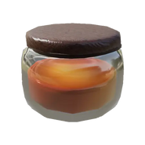](https://lord-of-the-rings-return-to-moria.fandom.com/wiki/Cave_Honey)

[Cave Honey](https://lord-of-the-rings-return-to-moria.fandom.com/wiki/Cave_Honey)

[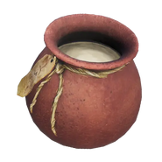](https://lord-of-the-rings-return-to-moria.fandom.com/wiki/Dough)

[Dough](https://lord-of-the-rings-return-to-moria.fandom.com/wiki/Dough)

[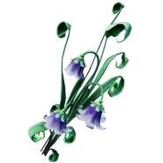](https://lord-of-the-rings-return-to-moria.fandom.com/wiki/Elbereth%27s_Blessing)

[Elbereth's Blessing](https://lord-of-the-rings-return-to-moria.fandom.com/wiki/Elbereth%27s_Blessing)

[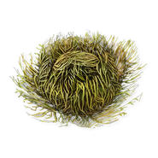](https://lord-of-the-rings-return-to-moria.fandom.com/wiki/Sunken_Moss)

[Sunken Moss](https://lord-of-the-rings-return-to-moria.fandom.com/wiki/Sunken_Moss)

Advertisement

Meals

Breakfast

[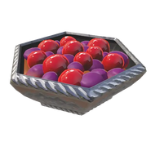](https://lord-of-the-rings-return-to-moria.fandom.com/wiki/Roasted_Cranberries)

[Roasted Cranberries](https://lord-of-the-rings-return-to-moria.fandom.com/wiki/Roasted_Cranberries)

[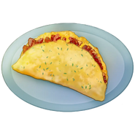](https://lord-of-the-rings-return-to-moria.fandom.com/wiki/King%27s_Omelette)

[King's Omelette](https://lord-of-the-rings-return-to-moria.fandom.com/wiki/King%27s_Omelette)

[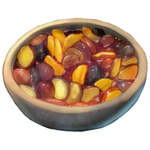](https://lord-of-the-rings-return-to-moria.fandom.com/wiki/Roasted_Fruit)

[Roasted Fruit](https://lord-of-the-rings-return-to-moria.fandom.com/wiki/Roasted_Fruit)

[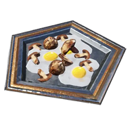](https://lord-of-the-rings-return-to-moria.fandom.com/wiki/Mushroom_Scramble)

[Mushroom Scramble](https://lord-of-the-rings-return-to-moria.fandom.com/wiki/Mushroom_Scramble)

[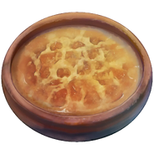](https://lord-of-the-rings-return-to-moria.fandom.com/wiki/Deep_Hash)

[Deep Hash](https://lord-of-the-rings-return-to-moria.fandom.com/wiki/Deep_Hash)

[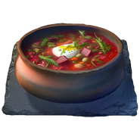](https://lord-of-the-rings-return-to-moria.fandom.com/wiki/Overnight_Bowl)

[Overnight Bowl](https://lord-of-the-rings-return-to-moria.fandom.com/wiki/Overnight_Bowl)

[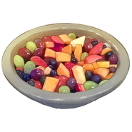](https://lord-of-the-rings-return-to-moria.fandom.com/wiki/Fruit_Salad)

[Fruit Salad](https://lord-of-the-rings-return-to-moria.fandom.com/wiki/Fruit_Salad)

[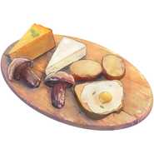](https://lord-of-the-rings-return-to-moria.fandom.com/wiki/Shire_Breakfast)

[Shire Breakfast](https://lord-of-the-rings-return-to-moria.fandom.com/wiki/Shire_Breakfast)

[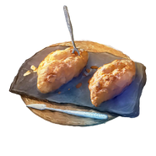](https://lord-of-the-rings-return-to-moria.fandom.com/wiki/Scones)

[Scones](https://lord-of-the-rings-return-to-moria.fandom.com/wiki/Scones)

[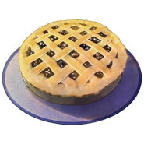](https://lord-of-the-rings-return-to-moria.fandom.com/wiki/Fruit_Pie)

[Fruit Pie](https://lord-of-the-rings-return-to-moria.fandom.com/wiki/Fruit_Pie)

[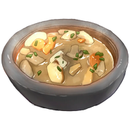](https://lord-of-the-rings-return-to-moria.fandom.com/wiki/Mushroom_Stew)

[Mushroom Stew](https://lord-of-the-rings-return-to-moria.fandom.com/wiki/Mushroom_Stew)

[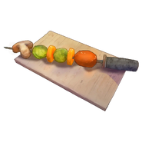](https://lord-of-the-rings-return-to-moria.fandom.com/wiki/Medley_Skewers)

[Medley Skewers](https://lord-of-the-rings-return-to-moria.fandom.com/wiki/Medley_Skewers)

[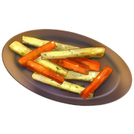](https://lord-of-the-rings-return-to-moria.fandom.com/wiki/Roasted_Parsnips)

[Roasted Parsnips](https://lord-of-the-rings-return-to-moria.fandom.com/wiki/Roasted_Parsnips)

[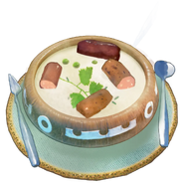](https://lord-of-the-rings-return-to-moria.fandom.com/wiki/Bangers_and_Mash)

[Bangers and Mash](https://lord-of-the-rings-return-to-moria.fandom.com/wiki/Bangers_and_Mash)

[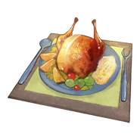](https://lord-of-the-rings-return-to-moria.fandom.com/wiki/Mashed_Potatoes)

[Mashed Potatoes](https://lord-of-the-rings-return-to-moria.fandom.com/wiki/Mashed_Potatoes)

[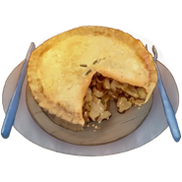](https://lord-of-the-rings-return-to-moria.fandom.com/wiki/Mushroom_Pie)

[Mushroom Pie](https://lord-of-the-rings-return-to-moria.fandom.com/wiki/Mushroom_Pie)

[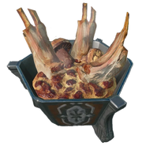](https://lord-of-the-rings-return-to-moria.fandom.com/wiki/Rohan_Yer%C3%AAg_Stew)

[Rohan Yerêg Stew](https://lord-of-the-rings-return-to-moria.fandom.com/wiki/Rohan_Yer%C3%AAg_Stew)

[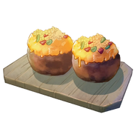](https://lord-of-the-rings-return-to-moria.fandom.com/wiki/Stuffed_Mushrooms)

[Stuffed Mushrooms](https://lord-of-the-rings-return-to-moria.fandom.com/wiki/Stuffed_Mushrooms)

[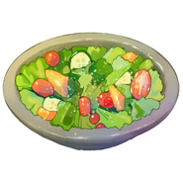](https://lord-of-the-rings-return-to-moria.fandom.com/wiki/Refreshing_Salad)

[Refreshing Salad](https://lord-of-the-rings-return-to-moria.fandom.com/wiki/Refreshing_Salad)

[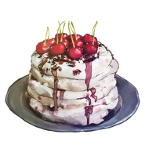](https://lord-of-the-rings-return-to-moria.fandom.com/wiki/Krumkake)

[Krumkake](https://lord-of-the-rings-return-to-moria.fandom.com/wiki/Krumkake)

[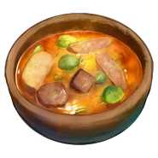](https://lord-of-the-rings-return-to-moria.fandom.com/wiki/Fire_Roasted_Stew)

[Fire Roasted Stew](https://lord-of-the-rings-return-to-moria.fandom.com/wiki/Fire_Roasted_Stew)

[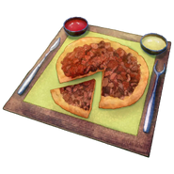](https://lord-of-the-rings-return-to-moria.fandom.com/wiki/Meat_Pie)

[Meat Pie](https://lord-of-the-rings-return-to-moria.fandom.com/wiki/Meat_Pie)

Advertisement

Dinner

[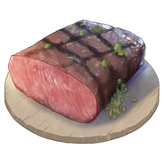](https://lord-of-the-rings-return-to-moria.fandom.com/wiki/Roast_Meat)

[Roast Meat](https://lord-of-the-rings-return-to-moria.fandom.com/wiki/Roast_Meat)

[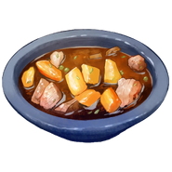](https://lord-of-the-rings-return-to-moria.fandom.com/wiki/Meat_Stew)

[Meat Stew](https://lord-of-the-rings-return-to-moria.fandom.com/wiki/Meat_Stew)

[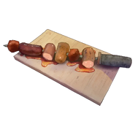](https://lord-of-the-rings-return-to-moria.fandom.com/wiki/Glazed_Meat_Skewers)

[Glazed Meat Skewers](https://lord-of-the-rings-return-to-moria.fandom.com/wiki/Glazed_Meat_Skewers)

[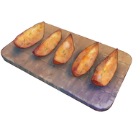](https://lord-of-the-rings-return-to-moria.fandom.com/wiki/Helm-fried_Chips)

[Helm-fried Chips](https://lord-of-the-rings-return-to-moria.fandom.com/wiki/Helm-fried_Chips)

[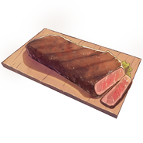](https://lord-of-the-rings-return-to-moria.fandom.com/wiki/Erebor_Strip_Steak)

[Erebor Strip Steak](https://lord-of-the-rings-return-to-moria.fandom.com/wiki/Erebor_Strip_Steak)

[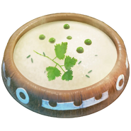](https://lord-of-the-rings-return-to-moria.fandom.com/wiki/Smashed_Curry)

[Smashed Curry](https://lord-of-the-rings-return-to-moria.fandom.com/wiki/Smashed_Curry)

[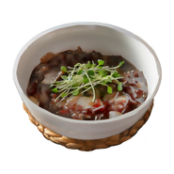](https://lord-of-the-rings-return-to-moria.fandom.com/wiki/Tagine)

[Tagine](https://lord-of-the-rings-return-to-moria.fandom.com/wiki/Tagine)

[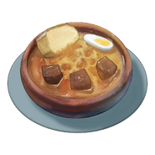](https://lord-of-the-rings-return-to-moria.fandom.com/wiki/Rommegrot_Pudding)

[Rommegrot Pudding](https://lord-of-the-rings-return-to-moria.fandom.com/wiki/Rommegrot_Pudding)

[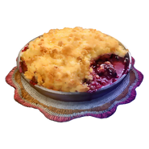](https://lord-of-the-rings-return-to-moria.fandom.com/wiki/Cranachan)

[Cranachan](https://lord-of-the-rings-return-to-moria.fandom.com/wiki/Cranachan)

[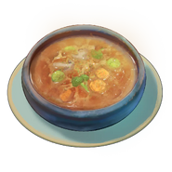](https://lord-of-the-rings-return-to-moria.fandom.com/wiki/Nana%27s_Casserole)

[Nana's Casserole](https://lord-of-the-rings-return-to-moria.fandom.com/wiki/Nana%27s_Casserole)

[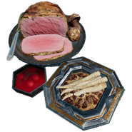](https://lord-of-the-rings-return-to-moria.fandom.com/wiki/Yule-tide_Feast)

[Yule-tide Feast](https://lord-of-the-rings-return-to-moria.fandom.com/wiki/Yule-tide_Feast)

Advertisement

Rations

[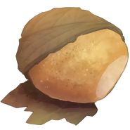](https://lord-of-the-rings-return-to-moria.fandom.com/wiki/Lembas)

[Lembas](https://lord-of-the-rings-return-to-moria.fandom.com/wiki/Lembas)

[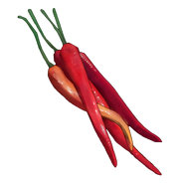](https://lord-of-the-rings-return-to-moria.fandom.com/wiki/Dried_Fruit)

[Dried Fruit](https://lord-of-the-rings-return-to-moria.fandom.com/wiki/Dried_Fruit)

[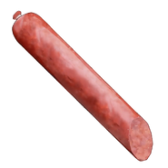](https://lord-of-the-rings-return-to-moria.fandom.com/wiki/Biltong)

[Biltong](https://lord-of-the-rings-return-to-moria.fandom.com/wiki/Biltong)

[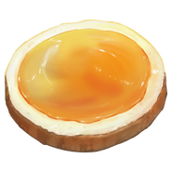](https://lord-of-the-rings-return-to-moria.fandom.com/wiki/Beorn%27s_Honey-cakes)

[Beorn's Honey-cakes](https://lord-of-the-rings-return-to-moria.fandom.com/wiki/Beorn%27s_Honey-cakes)

[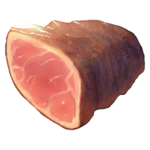](https://lord-of-the-rings-return-to-moria.fandom.com/wiki/Salted_Meat)

[Salted Meat](https://lord-of-the-rings-return-to-moria.fandom.com/wiki/Salted_Meat)

[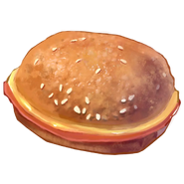](https://lord-of-the-rings-return-to-moria.fandom.com/wiki/Cram)

[Cram](https://lord-of-the-rings-return-to-moria.fandom.com/wiki/Cram)

[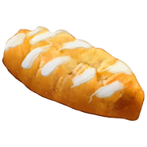](https://lord-of-the-rings-return-to-moria.fandom.com/wiki/Pasties)

[Pasties](https://lord-of-the-rings-return-to-moria.fandom.com/wiki/Pasties)

[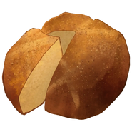](https://lord-of-the-rings-return-to-moria.fandom.com/wiki/Journey_Bread)

[Journey Bread](https://lord-of-the-rings-return-to-moria.fandom.com/wiki/Journey_Bread)

[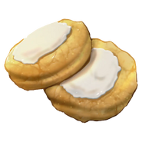](https://lord-of-the-rings-return-to-moria.fandom.com/wiki/Cookies)

[Cookies](https://lord-of-the-rings-return-to-moria.fandom.com/wiki/Cookies)

[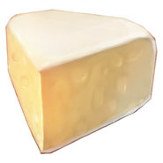](https://lord-of-the-rings-return-to-moria.fandom.com/wiki/Cheese)

[Cheese](https://lord-of-the-rings-return-to-moria.fandom.com/wiki/Cheese)

[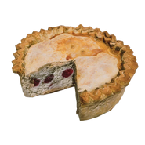](https://lord-of-the-rings-return-to-moria.fandom.com/wiki/Yule_Fruit_Crust-cake)

[Yule Fruit Crust-cake](https://lord-of-the-rings-return-to-moria.fandom.com/wiki/Yule_Fruit_Crust-cake)

Advertisement

Brews

[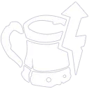](https://lord-of-the-rings-return-to-moria.fandom.com/wiki/Evening_Ale)

[Evening Ale](https://lord-of-the-rings-return-to-moria.fandom.com/wiki/Evening_Ale)

[](https://lord-of-the-rings-return-to-moria.fandom.com/wiki/Scour_Pilsner)

[Scour Pilsner](https://lord-of-the-rings-return-to-moria.fandom.com/wiki/Scour_Pilsner)

[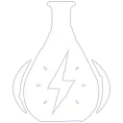](https://lord-of-the-rings-return-to-moria.fandom.com/wiki/Hopgoblet_Lager)

[Hopgoblet Lager](https://lord-of-the-rings-return-to-moria.fandom.com/wiki/Hopgoblet_Lager)

[](https://lord-of-the-rings-return-to-moria.fandom.com/wiki/Miruvor)

[Miruvor](https://lord-of-the-rings-return-to-moria.fandom.com/wiki/Miruvor)

[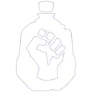](https://lord-of-the-rings-return-to-moria.fandom.com/wiki/Ironheart_Stout)

[Ironheart Stout](https://lord-of-the-rings-return-to-moria.fandom.com/wiki/Ironheart_Stout)

[](https://lord-of-the-rings-return-to-moria.fandom.com/wiki/Orkish_Medicine)

[Orkish Medicine](https://lord-of-the-rings-return-to-moria.fandom.com/wiki/Orkish_Medicine)

[](https://lord-of-the-rings-return-to-moria.fandom.com/wiki/Dawnbreak_Pale_Ale)

[Dawnbreak Pale Ale](https://lord-of-the-rings-return-to-moria.fandom.com/wiki/Dawnbreak_Pale_Ale)

[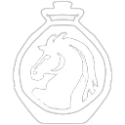](https://lord-of-the-rings-return-to-moria.fandom.com/wiki/Smoked_Mead)

[Smoked Mead](https://lord-of-the-rings-return-to-moria.fandom.com/wiki/Smoked_Mead)

[](https://lord-of-the-rings-return-to-moria.fandom.com/wiki/Mulled_Cider)

[Mulled Cider](https://lord-of-the-rings-return-to-moria.fandom.com/wiki/Mulled_Cider)

[[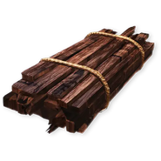](https://lord-of-the-rings-return-to-moria.fandom.com/wiki/Wood_Scraps)](https://lord-of-the-rings-return-to-moria.fandom.com/wiki/Wood_Scraps)

[Wood Scraps](https://lord-of-the-rings-return-to-moria.fandom.com/wiki/Wood_Scraps)

[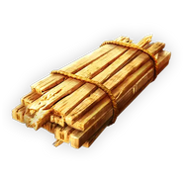](https://lord-of-the-rings-return-to-moria.fandom.com/wiki/Elven_Wood)

[Elven Wood](https://lord-of-the-rings-return-to-moria.fandom.com/wiki/Elven_Wood)

[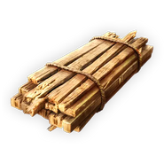](https://lord-of-the-rings-return-to-moria.fandom.com/wiki/Ub%C8%83sam_Wood)

[Ubȃsam Wood](https://lord-of-the-rings-return-to-moria.fandom.com/wiki/Ub%C8%83sam_Wood)

[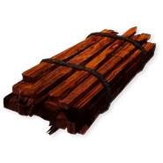](https://lord-of-the-rings-return-to-moria.fandom.com/wiki/Ironwood)

[Ironwood](https://lord-of-the-rings-return-to-moria.fandom.com/wiki/Ironwood)

Advertisement

Rock

[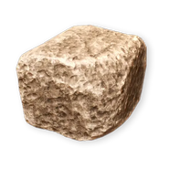](https://lord-of-the-rings-return-to-moria.fandom.com/wiki/Stone)

[Stone](https://lord-of-the-rings-return-to-moria.fandom.com/wiki/Stone)

[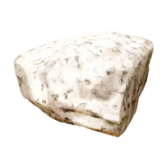](https://lord-of-the-rings-return-to-moria.fandom.com/wiki/Ihraz_Granite)

[Ihraz Granite](https://lord-of-the-rings-return-to-moria.fandom.com/wiki/Ihraz_Granite)

[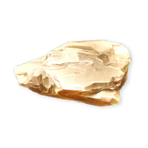](https://lord-of-the-rings-return-to-moria.fandom.com/wiki/Adamant)

[Adamant](https://lord-of-the-rings-return-to-moria.fandom.com/wiki/Adamant)

Ore

[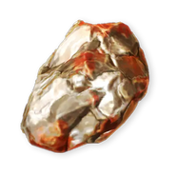](https://lord-of-the-rings-return-to-moria.fandom.com/wiki/Iron_Ore)

[Iron Ore](https://lord-of-the-rings-return-to-moria.fandom.com/wiki/Iron_Ore)

[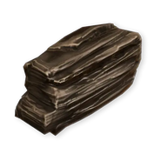](https://lord-of-the-rings-return-to-moria.fandom.com/wiki/Coal)

[Coal](https://lord-of-the-rings-return-to-moria.fandom.com/wiki/Coal)

[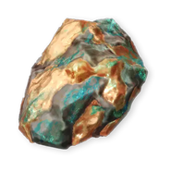](https://lord-of-the-rings-return-to-moria.fandom.com/wiki/Copper_Ore)

[Copper Ore](https://lord-of-the-rings-return-to-moria.fandom.com/wiki/Copper_Ore)

[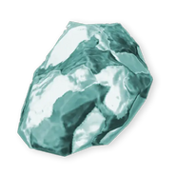](https://lord-of-the-rings-return-to-moria.fandom.com/wiki/Tin_Ore)

[Tin Ore](https://lord-of-the-rings-return-to-moria.fandom.com/wiki/Tin_Ore)

[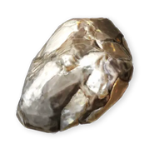](https://lord-of-the-rings-return-to-moria.fandom.com/wiki/Silver_Ore)

[Silver Ore](https://lord-of-the-rings-return-to-moria.fandom.com/wiki/Silver_Ore)

[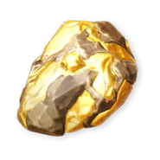](https://lord-of-the-rings-return-to-moria.fandom.com/wiki/Gold_Ore)

[Gold Ore](https://lord-of-the-rings-return-to-moria.fandom.com/wiki/Gold_Ore)

[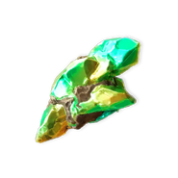](https://lord-of-the-rings-return-to-moria.fandom.com/wiki/Star-metal_Ore)

[Star-metal Ore](https://lord-of-the-rings-return-to-moria.fandom.com/wiki/Star-metal_Ore)

[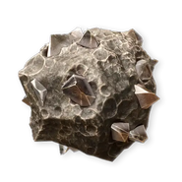](https://lord-of-the-rings-return-to-moria.fandom.com/wiki/Mithril_Ore)

[Mithril Ore](https://lord-of-the-rings-return-to-moria.fandom.com/wiki/Mithril_Ore)

[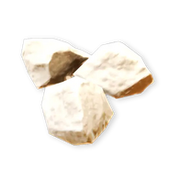](https://lord-of-the-rings-return-to-moria.fandom.com/wiki/Salt)

[Salt](https://lord-of-the-rings-return-to-moria.fandom.com/wiki/Salt)

[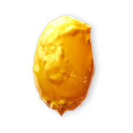](https://lord-of-the-rings-return-to-moria.fandom.com/wiki/Resin)

[Resin](https://lord-of-the-rings-return-to-moria.fandom.com/wiki/Resin)

[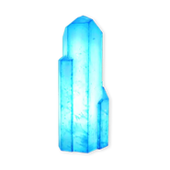](https://lord-of-the-rings-return-to-moria.fandom.com/wiki/True-quartz)

[True-quartz](https://lord-of-the-rings-return-to-moria.fandom.com/wiki/True-quartz)

[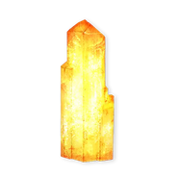](https://lord-of-the-rings-return-to-moria.fandom.com/wiki/Sun-stone)

[Sun-stone](https://lord-of-the-rings-return-to-moria.fandom.com/wiki/Sun-stone)

[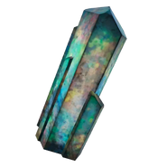](https://lord-of-the-rings-return-to-moria.fandom.com/wiki/Arrizite)

[Arrizite](https://lord-of-the-rings-return-to-moria.fandom.com/wiki/Arrizite)

Advertisement

Metals

[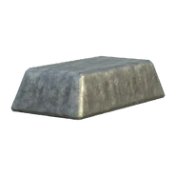](https://lord-of-the-rings-return-to-moria.fandom.com/wiki/Iron_Ingot)

[Iron Ingot](https://lord-of-the-rings-return-to-moria.fandom.com/wiki/Iron_Ingot)

[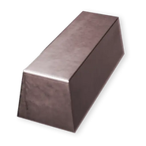](https://lord-of-the-rings-return-to-moria.fandom.com/wiki/Steel_Ingot)

[Steel Ingot](https://lord-of-the-rings-return-to-moria.fandom.com/wiki/Steel_Ingot)

[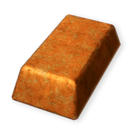](https://lord-of-the-rings-return-to-moria.fandom.com/wiki/Copper_Ingot)

[Copper Ingot](https://lord-of-the-rings-return-to-moria.fandom.com/wiki/Copper_Ingot)

[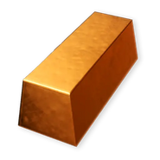](https://lord-of-the-rings-return-to-moria.fandom.com/wiki/Bronze_Ingot)

[Bronze Ingot](https://lord-of-the-rings-return-to-moria.fandom.com/wiki/Bronze_Ingot)

[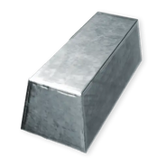](https://lord-of-the-rings-return-to-moria.fandom.com/wiki/Silver_Ingot)

[Silver Ingot](https://lord-of-the-rings-return-to-moria.fandom.com/wiki/Silver_Ingot)

[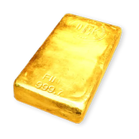](https://lord-of-the-rings-return-to-moria.fandom.com/wiki/Gold_Ingot)

[Gold Ingot](https://lord-of-the-rings-return-to-moria.fandom.com/wiki/Gold_Ingot)

[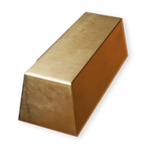](https://lord-of-the-rings-return-to-moria.fandom.com/wiki/Shan%C3%B4r_Ingot)

[Shanôr Ingot](https://lord-of-the-rings-return-to-moria.fandom.com/wiki/Shan%C3%B4r_Ingot)

[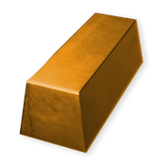](https://lord-of-the-rings-return-to-moria.fandom.com/wiki/Khaz%C3%A2d_Steel_Ingot)

[Khazâd Steel Ingot](https://lord-of-the-rings-return-to-moria.fandom.com/wiki/Khaz%C3%A2d_Steel_Ingot)

[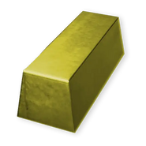](https://lord-of-the-rings-return-to-moria.fandom.com/wiki/Nogrod_Steel_Ingot)

[Nogrod Steel Ingot](https://lord-of-the-rings-return-to-moria.fandom.com/wiki/Nogrod_Steel_Ingot)

[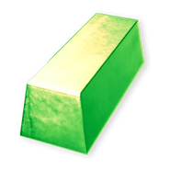](https://lord-of-the-rings-return-to-moria.fandom.com/wiki/Star-metal_Ingot)

[Star-metal Ingot](https://lord-of-the-rings-return-to-moria.fandom.com/wiki/Star-metal_Ingot)

[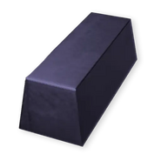](https://lord-of-the-rings-return-to-moria.fandom.com/wiki/Durinul_Iron_Ingot)

[Durinul Iron Ingot](https://lord-of-the-rings-return-to-moria.fandom.com/wiki/Durinul_Iron_Ingot)

[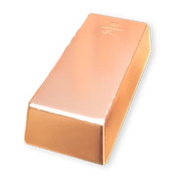](https://lord-of-the-rings-return-to-moria.fandom.com/wiki/Mithril_Ingot)

[Mithril Ingot](https://lord-of-the-rings-return-to-moria.fandom.com/wiki/Mithril_Ingot)

Advertisement

Gems

[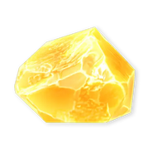](https://lord-of-the-rings-return-to-moria.fandom.com/wiki/Amber)

[Amber](https://lord-of-the-rings-return-to-moria.fandom.com/wiki/Amber)

[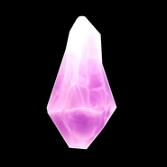](https://lord-of-the-rings-return-to-moria.fandom.com/wiki/Amethyst)

[Amethyst](https://lord-of-the-rings-return-to-moria.fandom.com/wiki/Amethyst)

[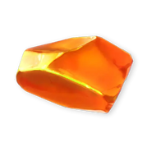](https://lord-of-the-rings-return-to-moria.fandom.com/wiki/Anorin)

[Anorin](https://lord-of-the-rings-return-to-moria.fandom.com/wiki/Anorin)

[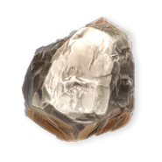](https://lord-of-the-rings-return-to-moria.fandom.com/wiki/Black_Diamond)

[Black Diamond](https://lord-of-the-rings-return-to-moria.fandom.com/wiki/Black_Diamond)

[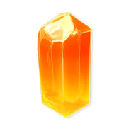](https://lord-of-the-rings-return-to-moria.fandom.com/wiki/Citrine)

[Citrine](https://lord-of-the-rings-return-to-moria.fandom.com/wiki/Citrine)

[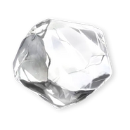](https://lord-of-the-rings-return-to-moria.fandom.com/wiki/Diamond)

[Diamond](https://lord-of-the-rings-return-to-moria.fandom.com/wiki/Diamond)

[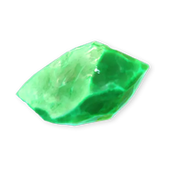](https://lord-of-the-rings-return-to-moria.fandom.com/wiki/Emerald)

[Emerald](https://lord-of-the-rings-return-to-moria.fandom.com/wiki/Emerald)

[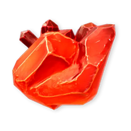](https://lord-of-the-rings-return-to-moria.fandom.com/wiki/Garnet)

[Garnet](https://lord-of-the-rings-return-to-moria.fandom.com/wiki/Garnet)

[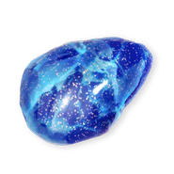](https://lord-of-the-rings-return-to-moria.fandom.com/wiki/Iolite)

[Iolite](https://lord-of-the-rings-return-to-moria.fandom.com/wiki/Iolite)

[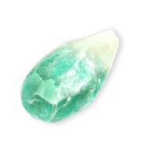](https://lord-of-the-rings-return-to-moria.fandom.com/wiki/Jade)

[Jade](https://lord-of-the-rings-return-to-moria.fandom.com/wiki/Jade)

[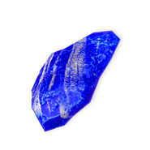](https://lord-of-the-rings-return-to-moria.fandom.com/wiki/Zel%C3%AAb)

[Zelêb](https://lord-of-the-rings-return-to-moria.fandom.com/wiki/Zel%C3%AAb)

[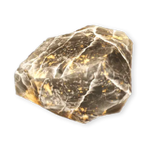](https://lord-of-the-rings-return-to-moria.fandom.com/wiki/Onyx)

[Onyx](https://lord-of-the-rings-return-to-moria.fandom.com/wiki/Onyx)

[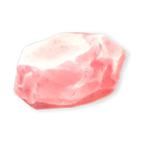](https://lord-of-the-rings-return-to-moria.fandom.com/wiki/Pink_Opal)

[Pink Opal](https://lord-of-the-rings-return-to-moria.fandom.com/wiki/Pink_Opal)

[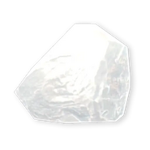](https://lord-of-the-rings-return-to-moria.fandom.com/wiki/Quartz)

[Quartz](https://lord-of-the-rings-return-to-moria.fandom.com/wiki/Quartz)

[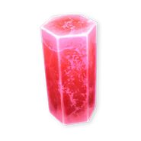](https://lord-of-the-rings-return-to-moria.fandom.com/wiki/Red_Beryl)

[Red Beryl](https://lord-of-the-rings-return-to-moria.fandom.com/wiki/Red_Beryl)

[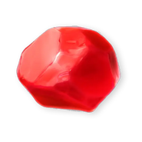](https://lord-of-the-rings-return-to-moria.fandom.com/wiki/Ruby)

[Ruby](https://lord-of-the-rings-return-to-moria.fandom.com/wiki/Ruby)

[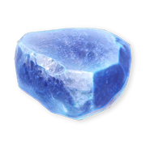](https://lord-of-the-rings-return-to-moria.fandom.com/wiki/Sapphire)

[Sapphire](https://lord-of-the-rings-return-to-moria.fandom.com/wiki/Sapphire)

[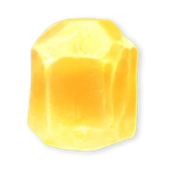](https://lord-of-the-rings-return-to-moria.fandom.com/wiki/Topaz)

[Topaz](https://lord-of-the-rings-return-to-moria.fandom.com/wiki/Topaz)

Advertisement

Fabrics

[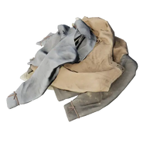](https://lord-of-the-rings-return-to-moria.fandom.com/wiki/Cloth_Scraps)

[Cloth Scraps](https://lord-of-the-rings-return-to-moria.fandom.com/wiki/Cloth_Scraps)

[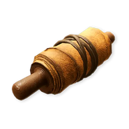](https://lord-of-the-rings-return-to-moria.fandom.com/wiki/Numenorean_Cloth)

[Numenorean Cloth](https://lord-of-the-rings-return-to-moria.fandom.com/wiki/Numenorean_Cloth)

[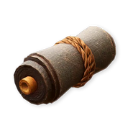](https://lord-of-the-rings-return-to-moria.fandom.com/wiki/Fine_Cloth)

[Fine Cloth](https://lord-of-the-rings-return-to-moria.fandom.com/wiki/Fine_Cloth)

Materials

[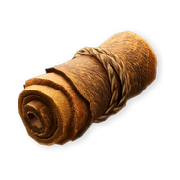](https://lord-of-the-rings-return-to-moria.fandom.com/wiki/Hide)

[Hide](https://lord-of-the-rings-return-to-moria.fandom.com/wiki/Hide)

[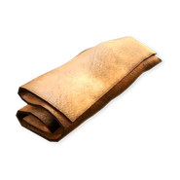](https://lord-of-the-rings-return-to-moria.fandom.com/wiki/Leather)

[Leather](https://lord-of-the-rings-return-to-moria.fandom.com/wiki/Leather)

[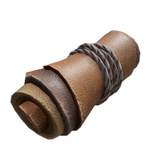](https://lord-of-the-rings-return-to-moria.fandom.com/wiki/Fine_Leather)

[Fine Leather](https://lord-of-the-rings-return-to-moria.fandom.com/wiki/Fine_Leather)

[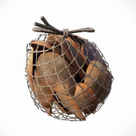](https://lord-of-the-rings-return-to-moria.fandom.com/wiki/Scales)

[Scales](https://lord-of-the-rings-return-to-moria.fandom.com/wiki/Scales)

[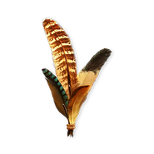](https://lord-of-the-rings-return-to-moria.fandom.com/wiki/Feathers)

[Feathers](https://lord-of-the-rings-return-to-moria.fandom.com/wiki/Feathers)

Special items

[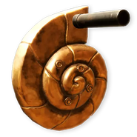](https://lord-of-the-rings-return-to-moria.fandom.com/wiki/Replacement_Crank)

[Replacement Crank](https://lord-of-the-rings-return-to-moria.fandom.com/wiki/Replacement_Crank)

[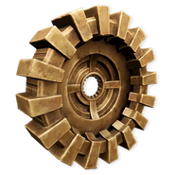](https://lord-of-the-rings-return-to-moria.fandom.com/wiki/Replacement_Gear)

[Replacement Gear](https://lord-of-the-rings-return-to-moria.fandom.com/wiki/Replacement_Gear)

[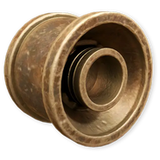](https://lord-of-the-rings-return-to-moria.fandom.com/wiki/Replacement_Pipe)

[Replacement Pipe](https://lord-of-the-rings-return-to-moria.fandom.com/wiki/Replacement_Pipe)